**971. Flip Binary Tree To Match Preorder Traversal**

Medium

389166Add to ListShare

You are given the root of a binary tree with n nodes, where each node is uniquely assigned a value from 1 to n. You are also given a sequence of n values voyage, which is the **desired** [**pre-order traversal**](https://en.wikipedia.org/wiki/Tree_traversal#Pre-order) of the binary tree.

Any node in the binary tree can be **flipped** by swapping its left and right subtrees. For example, flipping node 1 will have the following effect:

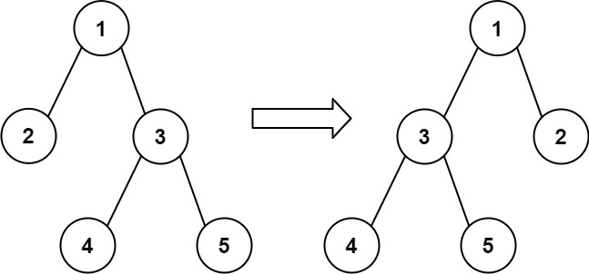

Flip the **smallest** number of nodes so that the **pre-order traversal** of the tree **matches** voyage.

Return *a list of the values of all****flipped****nodes. You may return the answer in****any order****. If it is****impossible****to flip the nodes in the tree to make the pre-order traversal match*voyage*, return the list*[-1].

**Example 1:**

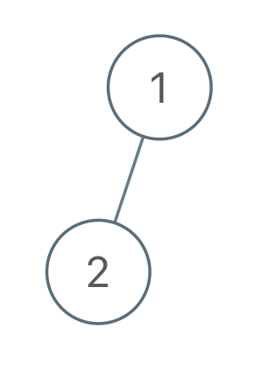

**Input:** root = [1,2], voyage = [2,1]

**Output:** [-1]

**Explanation:** It is impossible to flip the nodes such that the pre-order traversal matches voyage.

**Example 2:**

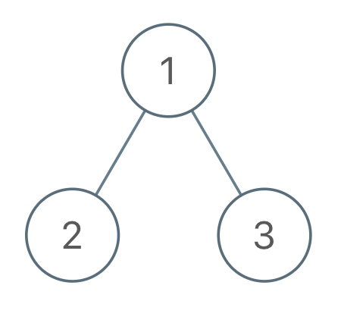

**Input:** root = [1,2,3], voyage = [1,3,2]

**Output:** [1]

**Explanation:** Flipping node 1 swaps nodes 2 and 3, so the pre-order traversal matches voyage.

**Example 3:**



**Input:** root = [1,2,3], voyage = [1,2,3]

**Output:** []

**Explanation:** The tree's pre-order traversal already matches voyage, so no nodes need to be flipped.

**Constraints:**

* The number of nodes in the tree is n.
* n == voyage.length
* 1 <= n <= 100
* 1 <= Node.val, voyage[i] <= n
* All the values in the tree are **unique**.
* All the values in voyage are **unique**.

Accepted

17,758

Submissions

37,584